10 September 2010

J-ISIS Project Presentation
- New multiplatform Free and Open Source Software (FOSS) CDS/ISIS that provides the same successful concepts and functionalities as the actual UNESCO WinISIS software.
- Removes CDS/ISIS database limitations.
- Client/Server architecture.
- UNICODE,
- Benefits of the latest software developments.
- Keep the assets and experience of the CDS/ISIS Users.
- Long-term solution developed to be modular, easy maintainable and extensible.
- J-ISIS application should be usable as a rich desktop application as well as a Web application

J-ISIS Desktop Application
- J-ISIS should be usable by small libraries and document centers in developing countries that don't have Internet access, or the necessary IT infrastructure and knowledge for installing a Web server.
- Easy to install application that provides a rich user interface.
- J-ISIS uses the client/server pattern and is a desktop application that acts as a database server as well as a rich client application.
- J-ISIS is a rich client application written to communicate with a specifically designed database server that is accessible as a stand-alone application and over some local network.
- It can be used on a single host machine, over a small local network, without Internet access or a Web server installed

J-ISIS Web, the J-ISIS Web Application
J-ISIS Web is a Rich Internet Application (RIA) whose goal is to develop a web top application that has the responsiveness, and look and feel of J-ISIS Desktop Application.
J-ISIS Web uses a Three-Tier Architecture
- Tier 1: At the client side, Web 2.0 technologies are responsible for the application's graphical user interface. AJAX is used to communicate between this tier and the application server in tier 2.

- Tier 2: the middle tier is also known as the application server. The server in the middle tier is a Web server capable of running Java-based Web applications (Tomcat, Jetty, etc).. Requests are passed as messages to the database server and results are returned. Sockets are used to communicate between this tier with the client and the database server through TCP/IP.

- Tier 3: the J-ISIS database server provides the data. The J-ISIS database server is listening for request on port 1111, requests and results are passed as messages through TCP/IP.
Please note that the J-ISIS desktop application and Web applications are complementary.

J-ISIS Main Features

- Compatibility with previous ISIS-databases by export/import (ISO2709)

- Dropping all CDS/ISIS existing DB- and record-limitations

- Fully UNICODE including the FDT, PFTs, FST, and FMTs that are now formatted in XML

The Master file concept remains, i.e. the Master file contains all the records of a given data base, each record consisting of a set of variable length fields. The Master file and Cross reference file are now replaced by a single Berkeley Database (Berkeley DB Java Edition) that contains an embedded B-Tree.

- Preserving the ISIS concept of variable-length data records identified by a unique number, automatically assigned by J-ISIS when it is created, called the Master File Number or MFN.

- Easy conversion of ISIS existing DB-structures (FDT,
FMT, FST, PFT)

- Formatting Language preserved(!), adding XHTML, JavaScript and CSS code capability within J-ISIS

- CDS/ISIS Pascal is replaced by the Groovy language. Groovy is a dynamic language (close to Java) for the Java™ Virtual Machine (JVM). It offers full object-orientation, and scripting. Groovy can be used to write specific applications as well as Format exits (Call from the PFT to external functions).

- J-ISIS provides a Groovy Console to write, test and execute Groovy scripts.

- The isis.dll library is replaced by the jisis-core.jar library and all methods and classes can be accessed through Groovy.

- A PFT manager offers a workspace for creating, editing, testing, converting and deleting PFTs. It contains also a PFT editor with syntax highlighting, Copy/Paste Undo/Redo, Syntax checking, PFT generation, etc...

- A FST manager offers a workspace for creating, editing, testing, converting and deleting FSTs

- New advanced worksheet editor that uses a Tree-Table layout and allows defining a worksheet that goes at the subfield level, define repetitive subfields and that may contain field indicators and implicit subfields.

- New advanced data entry editor that uses a Tree-Table layout and worksheets defined with the new advanced worksheet editor. It provides also interactivity for the basic functionality of entering, editing, viewing, or deleting records, that is, CRUD (Create Read Update Delete).

- Import/Export data recorded in Marc format (ISO 2709, Marc21, MarcXML, UNIMARC) and XML formats (MODS)

- The J-ISIS inverted file is created with Apache Lucene and the J-ISIS search engine is based on the Lucene API.

- The Inverted file contains all terms which may be used as access points during retrieval for a given data base, and, for each term, a list of references to the Master file record(s) from which the term was extracted. The collection of all access points for a given data base is called the dictionary. You may think of the Inverted file as an index to the contents of the Master file.

- J-ISIS provides two searching methods; Guided Search and an Expert Search which allow all Lucene capabilities. Guided search is the simpler of the two and only supports Boolean terms. The structure of the search is constrained by the user interface, making it difficult to enter incorrect queries. Expert search permits a wider range of searching functions including proximity searching and searching for repeatable fields.

- Fields that are indexed for searching are specified in the field selection table. Fields that are not indexed cannot be searched unless a free text search is used, which scans the entire contents of the records.

- Guided Search is selected by default. The new Guided Search module uses autocomplete user interface features that provide users with suggested queries or results as they type their query in the search box. This is also commonly called autosuggest or incremental search. J-ISIS autocomplete implementation is very fast even on large indices in under a few milliseconds so that the user sees results pop up as he types them.

- Much more …
How to get J-ISIS and J-ISIS Web:

J-ISIS Beta release 6 September 2010 | http://kenai.com/projects/j-isis/downloads/download/jisis_suite 6 September 2010.zip
J-ISIS Web | http://kenai.com/projects/j-isis/downloads/download/Web-JISIS3.war
J-ISIS Web Documentation | http://kenai.com/projects/j-isis/downloads/download/Web-JISIS.pdf
August 2010 J-ISIS Quick Tutorial | http://kenai.com/projects/j-isis/downloads/download/J-ISIS Quick Tutorial 2 August 2010.pdf

J-ISIS Project Status

- J-ISIS Desktop and Web applications are under heavy development and they are yet in Beta version for evaluation and testing.
- Databases and all related files such as indexes, FDT, FST, Worksheets, etc are fully UNICODE using UTF-8 encoding and are interoperable between different platforms (i.e. you can copy databases and indexes without conversion between Windows, Mac OS X and Linux.
Some Screen Shots
Database Menu | Browse
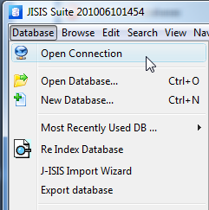 | 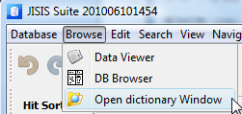
Data Viewer
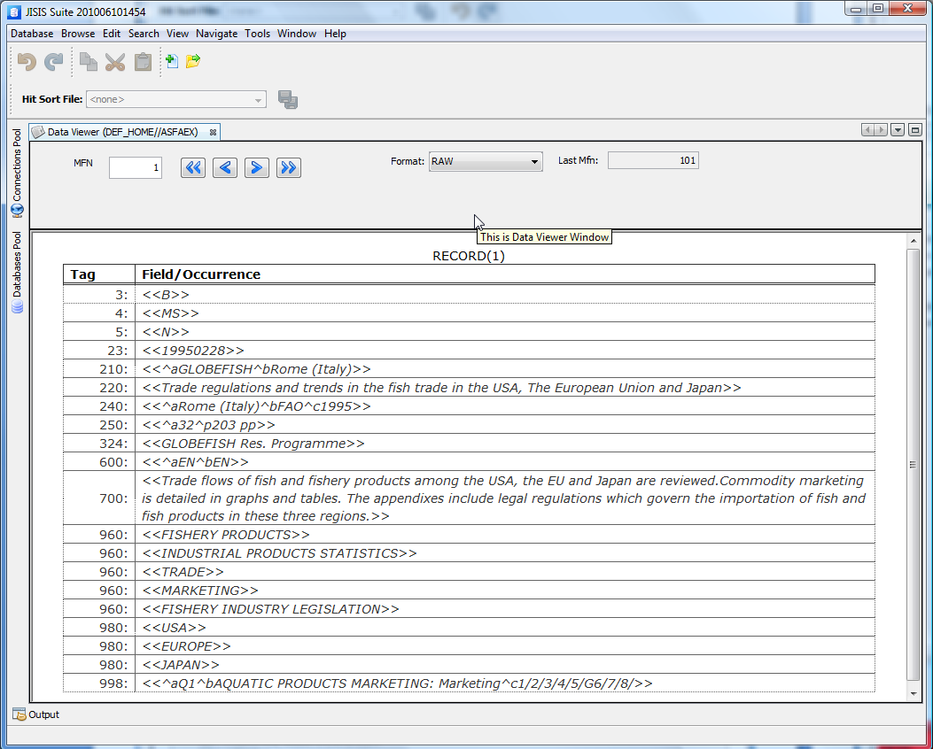
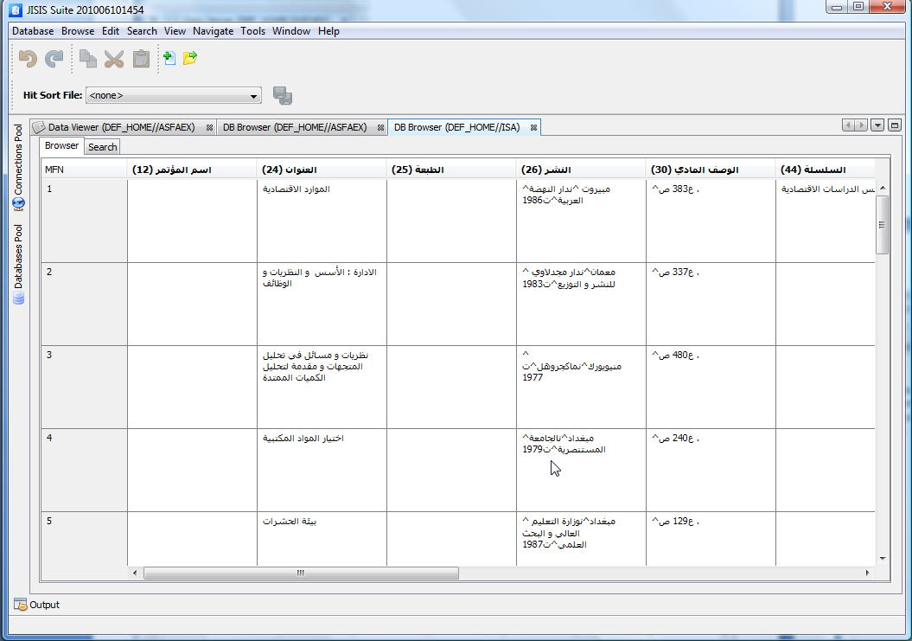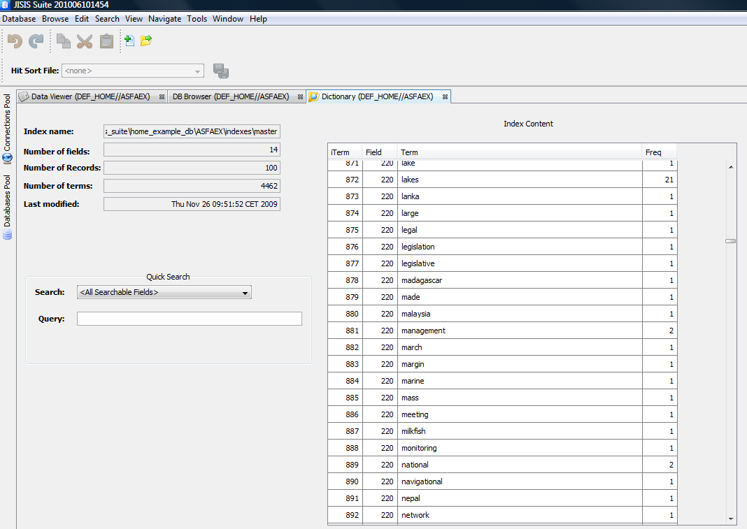

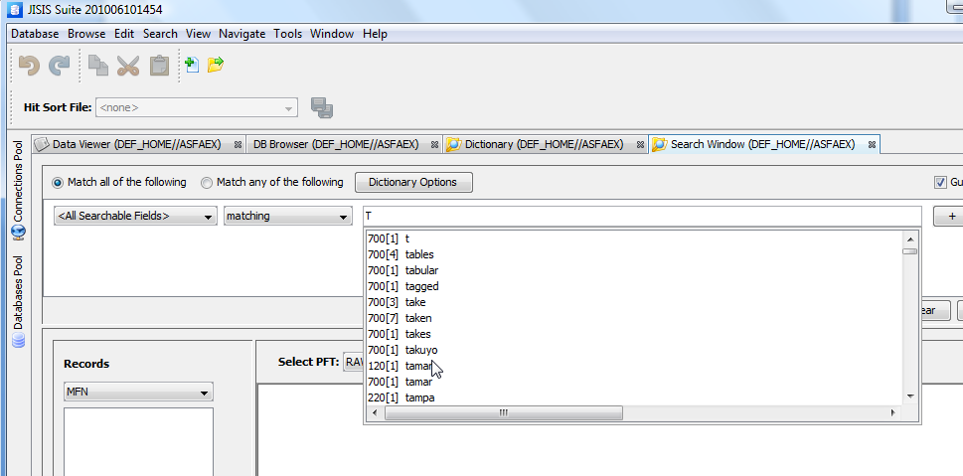
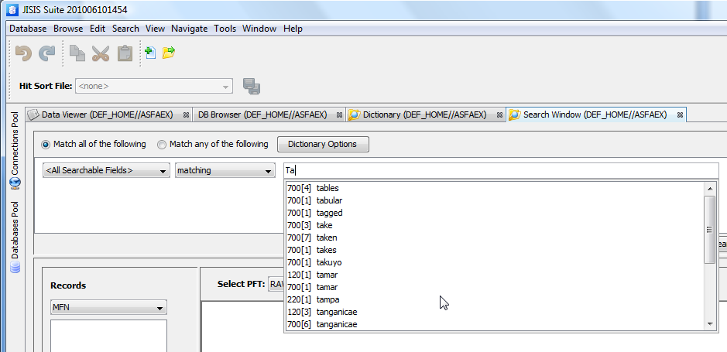

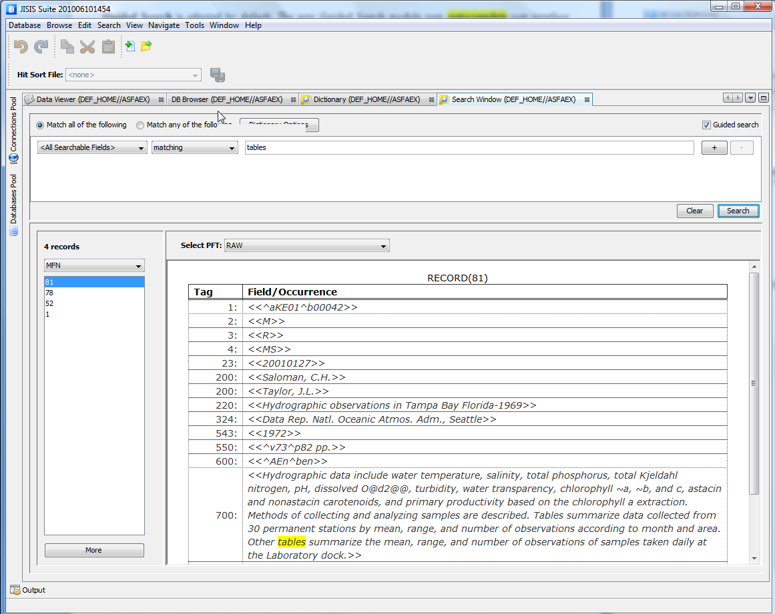
J-ISIS Web
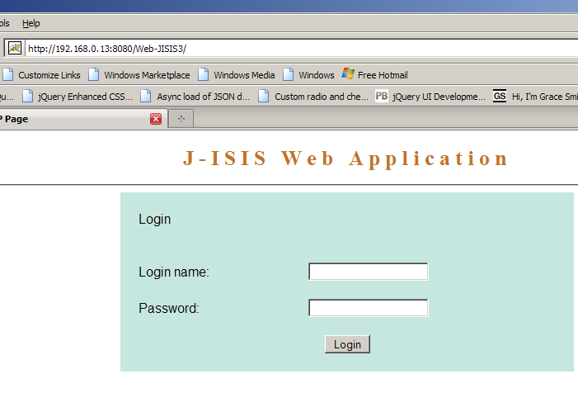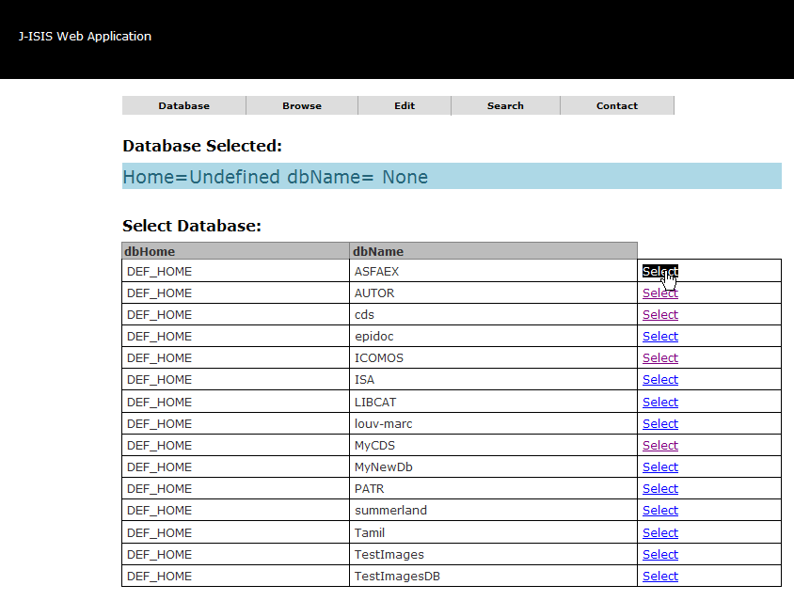
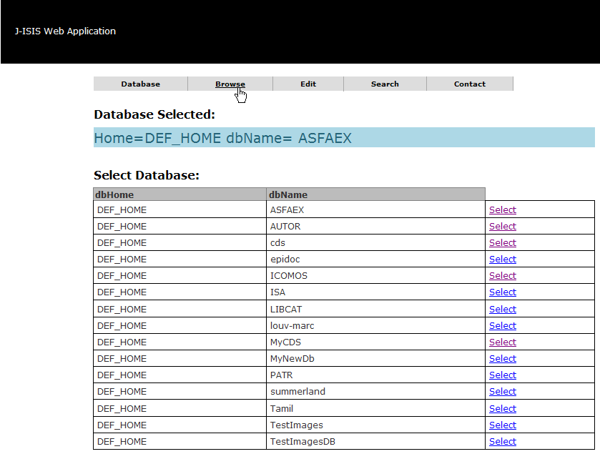
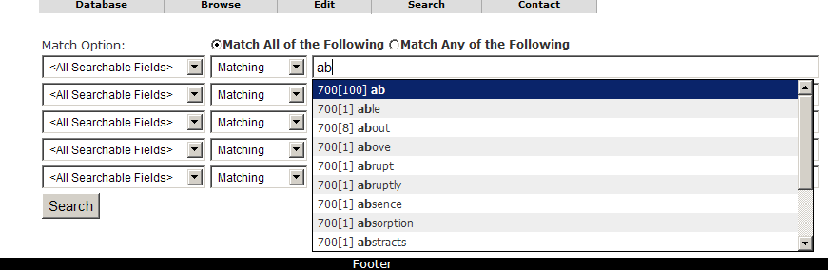
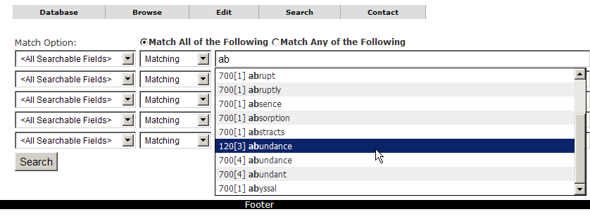
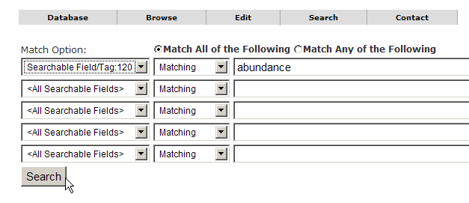
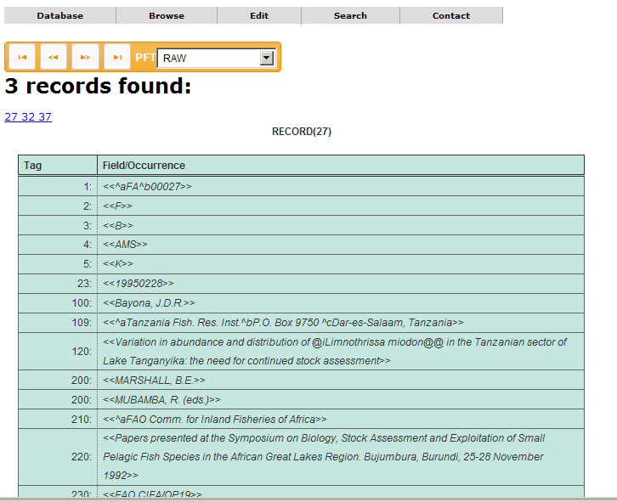
CRUD (Edit->Data Entry)
